**Community, Continuing Education, Workforce development and Library Services Area**

**The Educational Opportunity Fund Program**

***EOF at Essex***

***E.O.F. Matters – November ‘22***

The Monthly Newsletter from EOF at ECC!*

***Yes! November is a big month for Students and Staff!!!***

***Here are some important dates:***

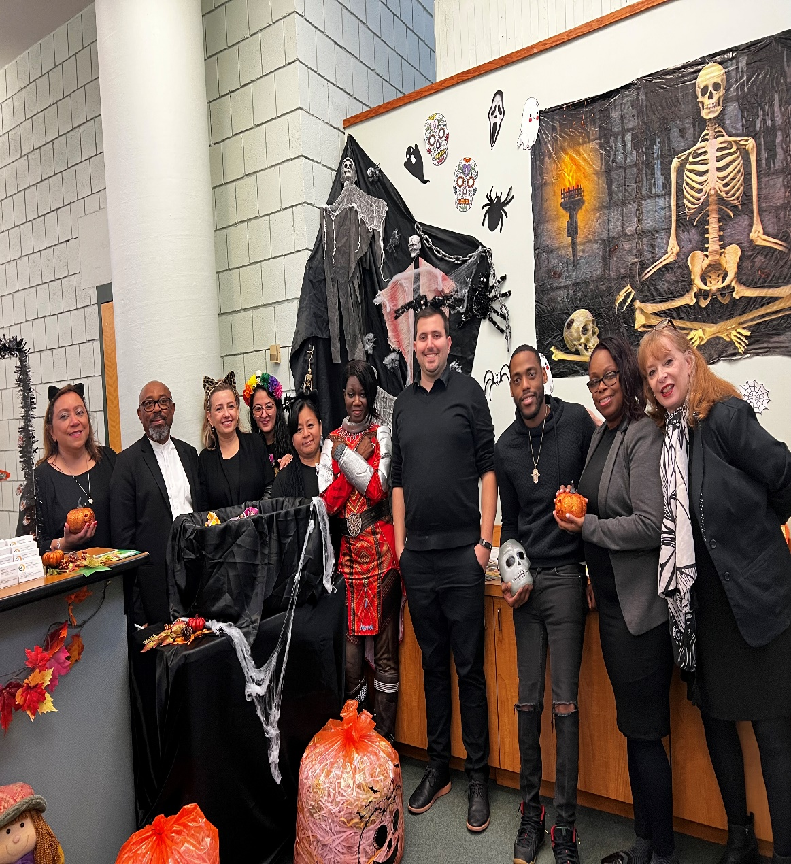**Vote – November 8!!!**

* **Nov 18 – Last day to withdraw**
* **Dec 20 –last day of classes**
* ***Thanksgiving --- 24, 25 – College Closed***
* ***Dec 23 --- 1st day of Winter Intersession – check in with your EOF***

***Counselor to get your tuition paid!!!***

***Come on over – or call us to get extra help with your studies:***

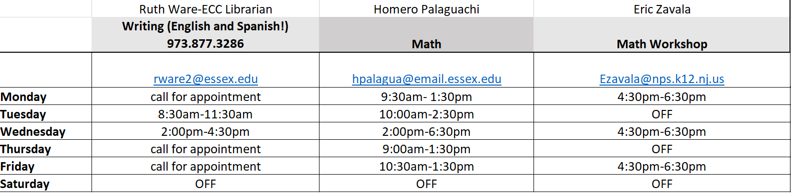

***Congratulations to our own David Hill, a graduate of ECC and an EOF alumn!!! He was recently promoted to Deanof Student Affairs at St Elizabeth’s University!!!***

***Wellness Wednesdays! Join us for mediation, green tea, and TLC!!! 12:30 in EOF Department – all are welcomed!***

Great News --- **Career Coach Tracy Cooper** is back with us to work with you on your career goals ---- she can help you decide what you want to be when you grow up (LOL) and also help with your resume, cover letters, Linked in accounts etc…. 908 977-6811 call for your very own appointment!

*Job Opening – Right here in EOF* --- Learning Associate needed for English and Chemistry ---- call or see Mike --- x3232!!!

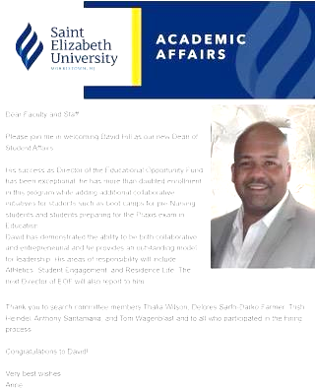***Alumni news-----***

***Dean David Hill! ---- Congratulations to David for his promotion to Dean of Student Affairs at St. Elizabeth University!!! He is a devoted EOF and ECC alum!!***



*EOF is a State of NJ and ECC sponsored support department for college students who hail from low income background --- Learn more: essex.edu/eof; visit – 3rd level, green Area!

***EOF – Get with the Program!!!!***